

SDV602 Milestone #1

Rory Folster



August 29, 2021

NMIT

Nelson

Contents

Application Description 1

Base Idea 1

Logging in / Account creation 2

Chat System 2

CSV Selection 2

Main Application 2

Storyboards 3

Storyboard 1 - App login 3

Storyboard 2 – Account Registration 4

Storyboard 3 – CSV Selection and Keywords 5

Storyboard 4 – Main Page 6

Storyboard 5 – Local File Selection 7

Storyboard 6 – Username or Password was incorrect 7

Storyboard 7 – Login Successful 8

Storyboard 8 – Exit Prompt 8

Storyboard 9 – Account Registered 9

Storyboard 10 – Changing Keyword Prompt 9

Storyboard 11 – Loading Prompt 10

# Application Description

## Base Idea

My SDV602 Python application is a data management application that will allow users to insert an CSV file of their selection from their local files.

The application will be coded with the ‘Python’ language, the charts will be created with a 3rd party library named ‘Matplotlib’ and the GUI for my application will be created with another 3rd party library named ‘PySimpleGUI’.

The purpose of the application is to provide the users with a useful application or tool that will allow them to search through and find certain information or data that is important to them and create chart that is easy to understand.

## Logging in / Account creation

When a user first opens the application, they are greeted with a login screen that will require a username and password.

If the users do not currently have an account, they will be able to create an account that will require a username, password and email address, they will be able to use their account details to login to the application.

This will be a great asset when using the text-based chat system, as it will allow the users to distinguish each other via their usernames.

The users accounts will be sent to and saved on a remote database system, this will make the application a lot more secure, it can also help cut time in the development of the application as I won’t have to manually code every row and table for the database.

## Chat System

The application will allow multiple users to connect to the current chart and will allow the users to communicate with each other through a text-based chat system, that will be embedded into the main page of the application.

The text of the chat system will be saved as a session locally and will deleted once the users have closed the screen they are sharing.

## CSV Selection

Once the user has logged into the application successfully, they will be meet with a screen that will allow the user/s to select a file locally saved onto their machine, and they will then be able to enter any ‘keywords’ that they would like to search for in their CSV file, such as ‘Failed Password’ or ‘root’.

A chart will then be produced on the main page of the application based on the parameters given. The user will be able to select between a Histogram Chart or a Pie Chart, I have picked these as I believe they will be best suited and most useful charts for my application.

## Main Application

Once the user has selected the file they wish to use, and have entered in their desired keywords, they will be displayed the main screen of the application. The main screen will consist of 2 buttons at the top of the screen, allowing the user/s to switch between a Histogram Chart or a Pie Chart display.

Below the buttons, the created graph will be displayed in a medium sized box, making it big enough to read comfortably. Beside the graph, there will be a chat-based system, consisting of a scrollable message box, a text box and a button. The button will allow the user to send their message, alternatively they can press the ‘Enter’ key for the same result. There will also be a small description of the graph, possibly a percentage of each result.

At the bottom of the main screen, there will be two buttons, one that will allow the user to change their keywords, changing the display of the chart and adding another level of usability to the program, the other button will allow the user to exit the application.

# Storyboards

## Storyboard 1 - App login

1.5

1.4

1.3

1.2

1.1

* 1. Username Input. Textbox that allows the user to enter their username attached previously created account.
  2. Password Input. Textbox that allows the user to enter their password attached to a previously created account.
  3. Login Button. Once the user has entered their username and password, the login button will send the request to the database to check the credentials, if the credentials are correct, a prompt will be displayed (Storyboard 7) and they will move to storyboard 3, if they are wrong move to storyboard 6.
  4. Register Button. If the user does not have a previously created an account, they will need to press this button. It will then bring the user to storyboard 2.
  5. Exit Button. This will allow the user to close the application after a prompted is displayed (Storyboard -----).

## Graphical user interface, application Description automatically generatedStoryboard 2 – Account Registration

2.5

2.6

2.4

2.3

2.2

2.1

* 1. Username Registration Input. Textbox that allows the user to enter their desired username that will be displayed in the application.
  2. Password Registration Input. Textbox that allows the user to enter their desired password for their account.
  3. Name Registration Input. Textbox that allows the user to enter their first name, this can help will account recovery and management within the database.
  4. Email Registration Input. Textbox that allows the user to enter their email address, this helps with account recovery and increases general security of their account.
  5. Register Account Button. This allows the user to submit their details, their details will then be saved in the database, allowing the user to login to their new account with their credentials.
  6. Exit Button. Allows the user to quit the application after a prompt (Storyboard ----).

## Graphical user interface, application Description automatically generatedStoryboard 3 – CSV Selection and Keywords

3.2

3.3

3.1

* 1. Browse local files button. This button allows the user to select a local file from their device. When this button is clicked the browse local files windows screen is displayed (Storyboard ----).
  2. Password Registration Input. Textbox that allows the user to enter their desired password for their account.
  3. Name Registration Input. Textbox that allows the user to enter their first name, this can help will account recovery and management within the database.

## Graphical user interface Description automatically generated with medium confidenceStoryboard 4 – Main Page

4.5

4.6

4.4

4.3

4.2

4.1

* 1. Change Histogram Button. This button allows the user to change the view of the graph to a Histogram Graph, possibly in a new screen or changing the current graph and updating it.
  2. Change Pie Button. This button allows the user to change the view of the graph to a Pie Graph, possibly in a new screen or changing the current graph and updating it.
  3. Graph Box. This is the graph that will be created with MatPlotLib, using the users CSV file and keywords.
  4. Chat Box. This chat system allows the users to communicate live. Allowing the users to talk about the current graph etc.
  5. Change keyword. This allows the user to change their previous keyword/s and add new ones, updating the graph. The user will be prompted, preventing the button from being activated on accident.
  6. Exit Button. Allows the user to exit the application after a prompt (Storyboard -----).

Side note – I may also include a search input box that will allow the users to enter keywords directly from the main screen, would like feedback on this idea please.

## Storyboard 5 – Local File Selection

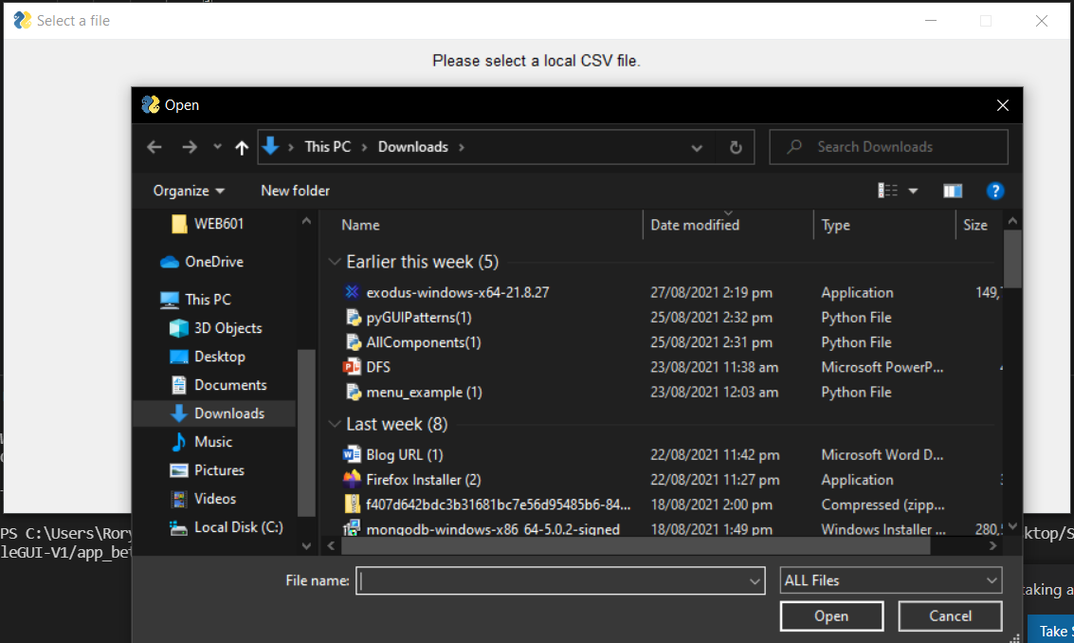

* 1. This screen allows the user to browse their local system.

## Storyboard 6 – Username or Password was incorrect

6.1 Wrong Credentials. Prompt displaying to the user that the credentials were incorrect. They will then return to the login screen to try again.

## Storyboard 7 – Login Successful

7.1 Login Successful. This displays to the user that the entered credentials were correct.

## Storyboard 8 – Exit Prompt

8.1 Exit Prompt. Asks the user if they are sure they want to exit. Prevents the user from accidentally pressing the exit button and closing the application.

## Graphical user interface Description automatically generatedStoryboard 9 – Account Registered

9.1 Successful Registration Prompt. This prompt displays to the user that their account has been created and they are now ready to login to the application.

## Storyboard 10 – Changing Keyword Prompt

10.1 Changing Keyword Prompt. This prompt asks the user if they are sure they want to change their keywords, this prompt helps to prevent the user from changing their keywords accidentally

## Graphical user interface, text, application Description automatically generatedStoryboard 11 – Loading Prompt

11.1 Loading Prompt. This is a possible prompt that I might need depending on how long the graphs take to be created. This will display to the user that their graph is being loaded and the application is still working.

Link to GitHub Repo for this project - https://github.com/Rory-Folster/SDV602_App_V1